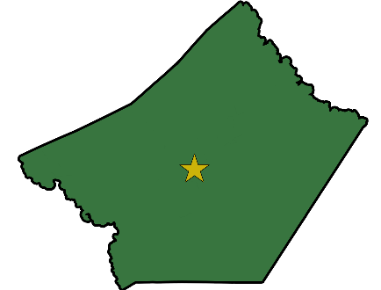
GUADALUPE COUNTY ENGINEER
310 IH 10 West
Seguin, Texas 78155
www.co.guadalupe.tx.us

Clay Forister, PE, CFM
COUNTY ENGINEER
(830) 303-4188 x1401 Office

EMPLOYMENT NOTICE

In compliance with the Guadalupe County Personnel Policy, it is mandatory that Department Heads post this notice for five (5) working days. This notice will be posted beginning October 19, 2022.

The County Engineer is accepting applications for the position of
Assistant County Engineer

Job Duties Include:

- Assisting the County Engineer in the supervision of assigned personnel and overseeing the surveying, design, and construction of County projects.
- Assisting in the subdivision process by reviewing plats and public infrastructure construction plans submitted by developers and maintaining files of maps, subdivision plats, and record drawings.
- Directing, monitoring and evaluating capital improvement construction projects and contracts of public works as well as all assigned divisions and presenting status reports of such projects on a timely basis.
- Providing direction to the engineering functions of surveying, mapping, and floodplain management and control and directing the preparation of plans, specifications, estimates, and contracts for major projects of street and utility construction.
- Reviewing plans submitted by Developer(s)/Engineer(s) for construction activity as a result of development.
- Coordinating with federal, regional, state and local agencies and utility companies as required.
- Acting as liaison between other counties, municipalities and State agencies.
- Working directly and in depth with citizens, employees, peers, supervisors, commissioners, and other department directors in problem resolution; including administrative work.
- Preparing and providing presentations to Commissioners Court, boards, committees, and to various groups and organizations as called upon.
- Representing the county on task forces and boards that relate to official capacity; and special projects.
- Assisting the general public with various issues regarding development and infrastructure.
- Coordinating projects with other governmental entities.

- Completing other duties as assigned.

Requirements/Qualifications Include:

- Bachelor of Science Degree (or Master’s Degree) in Civil Engineering
- Licensed Professional Engineer in the State of Texas
- Minimum of five (5) years related experience in public works projects
- Computer and related software, plotter, survey equipment, personal computers, spreadsheets, GIS, and CADD software
- Management of large-scale capital projects
- Direct supervisory experience, including diverse groups of subordinates
- Excellent interpersonal skills
- Experience in Flood Plain Management
- Valid Texas Driver’s License
- Plan and execute the design of major public works construction projects
- Knowledge and experience in reviewing plats and public infrastructure / construction plans
- Prepare specifications, estimates, work schedules, plans, maps and reports
- Knowledge of TxDOT, federal and local regulations as they apply to county projects
- Establish and maintain effective and positive working relationships with public officials, contractors, and with other county or local governmental departments
- Read, analyze and interpret technical and general business information, procedures and regulations
- Excellent leadership and interpersonal skills in dealing with internal and external customers
- Build excellent working relationships with regulatory agencies and the community
- Maintain regular and predictable attendance

This position pays up to $120,000 per year commensurate with experience. Benefits include Medical Insurance, Paid Holidays, Vacation, Sick Leave and Retirement. Employment starts April 1, 2023.

Applications and transfer requests may be obtained and completed from the county’s website (https://www.co.guadalupe.tx.us/employment/employment.php) or picked up at the Human Resources Office located at 211 W. Court, Seguin, TX. Please submit completed application and transfer requests to the County Engineer via e-mail at clay.forister@co.guadalupe.tx.us. Position is open until filled.

Guadalupe County does not discriminate on the basis of race, color, national origin, sex, religion, age, and handicapped status in employment or the provision of services.

